**Problem Statement**

● Run a map only job on the word count program using static configurations.

● Run the mapreduce word count program and set the number of reducers to 2 using static configurations.

1. Run a map only job on the word count program using static configurations.

Solution:

Driver Class:

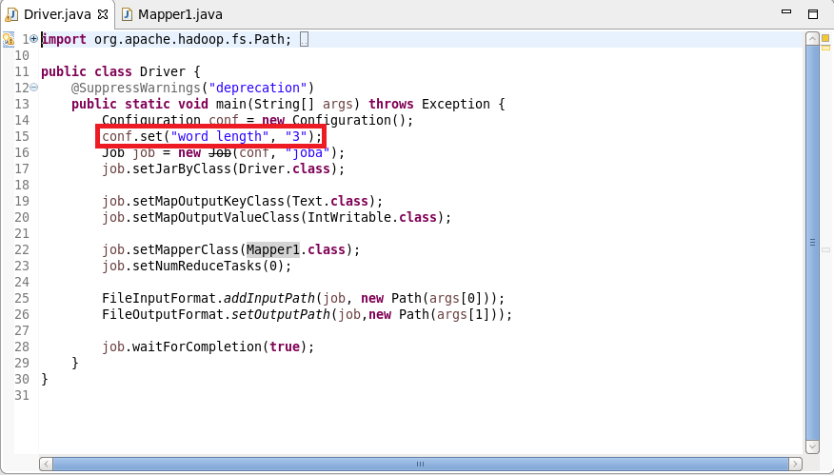

Mapper Class:

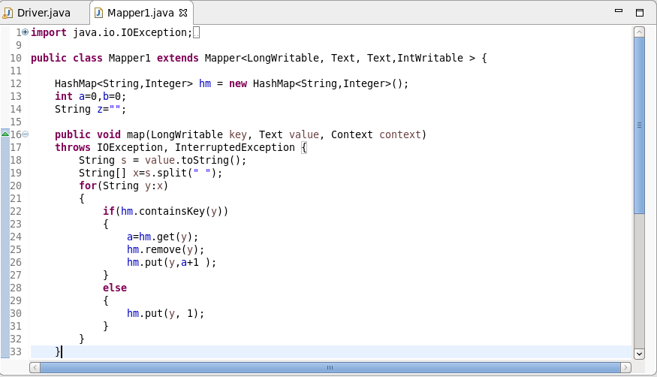

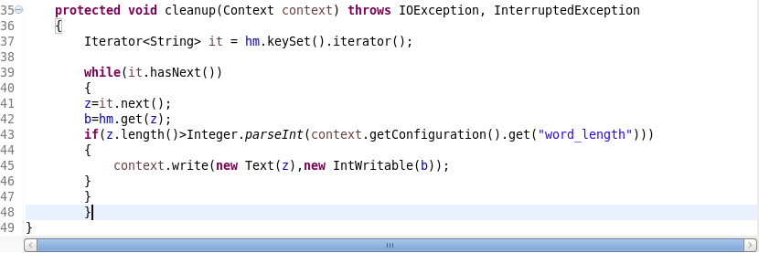

Execution command:

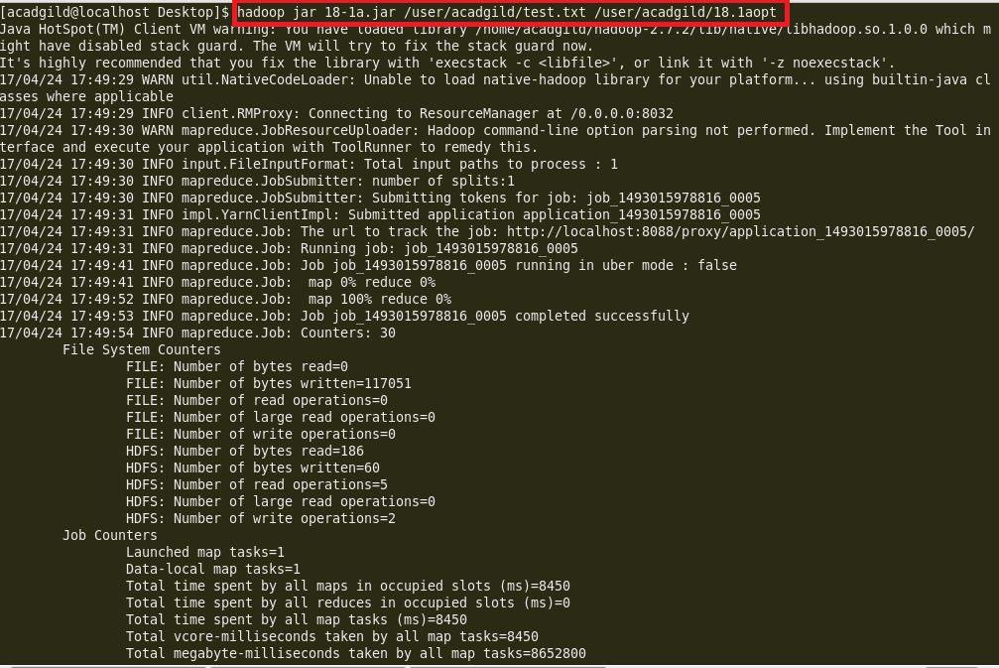

Output:

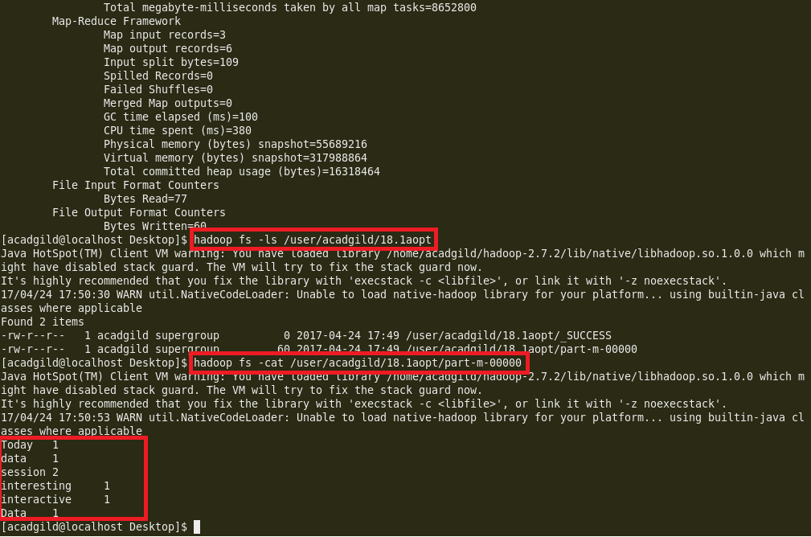

2. Run the mapreduce word count program and set the number of reducers to 2 using static configurations.

**Solution:**

Driver Class:

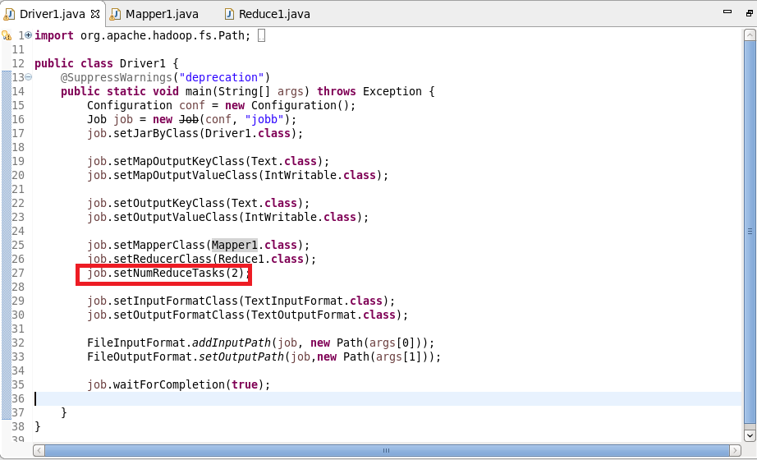

Mapper Class:

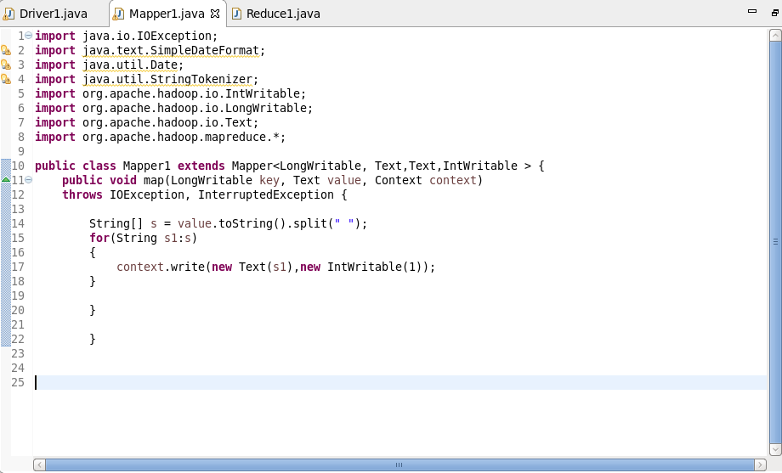

Reducer Class:

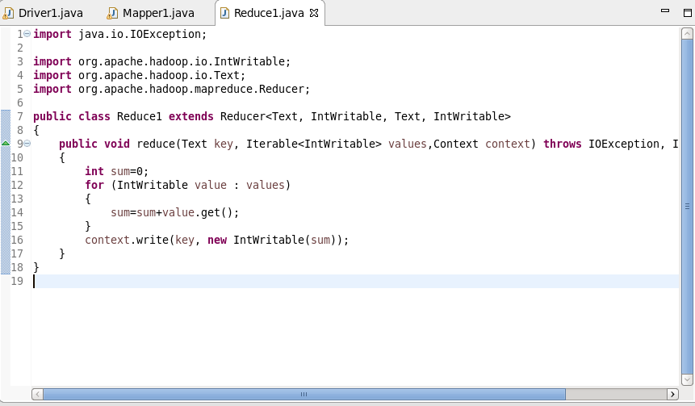

Execution command:

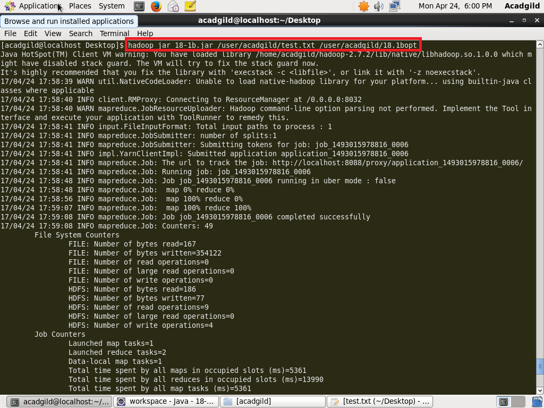

Output:

